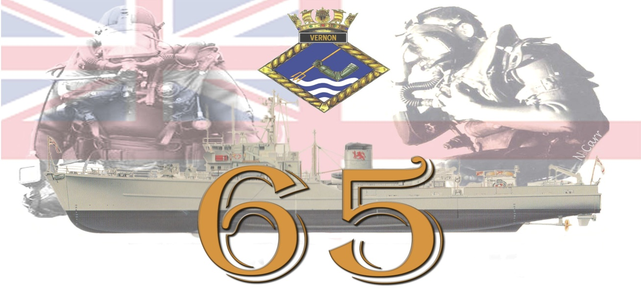

Anniversary
Royal Navy Clearance Divers Association Dinner

The Dinner is Open to all Serving and Retired Royal Naval Divers, Partners and Guests
Doors Open At 1900 where you will be greeted by the official photographer
And a welcome Drink followed by pre dinner drinks in the bar,
You will be asked to take your seats to eat at 2000
On completion of the meal there will be a Auction and raffle
The night will continue through until 0200 With entertainment from
local DJ a NONE cash mobile casino
Date: Saturday 14th Oct 2017 Time: 1900 until 0200
Venue: Plaza Suite the Pyramids Center Clarence Esplanade Southsea Portsmouth PO5 3ST
Dress: Formal /Association Tie
Cost: £37.50 per person for RNCDA members and One Guest,
Cost: £42.50 per person for Non-RNCDA Members and their Guests.
Menu is a 3 course meal, ½ bottle of wine and glass of port.
Starter:
Cream of Wild Mushroom Soup (V)
With Tarragon cream
Ham Hock Terrine
With a mild mustard pickle, pea puree and a toasted brioche
Main:
Roast Rump of Lamb
With dauphinoise potatoes, buttered cabbage, green beans and a redcurrant reduction
Pan Roasted Corn Fed Chicken
With dauphinoise potatoes, roasted root vegetables and a port reduction
Artichoke and Wild Mushroom Ravioli (V)
With mushrooms, sun blush tomatoes, grilled artichoke, seared pearl onion and celery cream sauce
Dessert:
Profiteroles
With warm chocolate sauce
Raspberry and Lavender Crème Brûlée
With raspberries and clotted cream

RNCDA Membership Applications are available via email, RNCDA@hotmail.co.uk

Event Applications Are Available From RNCDA.shop@hotmail.com

PLACES OR MEALS WILL NOT BE BOOKED UNTIL PAYMENT IS RECEIVED

Royal Navy Clearance Divers 65th Anniversary Dinner

Date: Saturday 14th October 2017 Time: 1900 Until 0200
Venue: Plaza Suite The Pyramids Center Clarence Esplanade
Southsea Po5 3st
Cost: £37.50 per person For Rncda Members And One Guest, Or
£42.50 per person For Non-Rncda Members And Their Guests.

RNCDA Member. If Member Please Insert Coin Number |  |  |  |  |  |  | Number
Name: (Guest 1)
Name (Guest 2)
Name (Guest 3)
Name (Guest 4)
Name (Guest 5)
Total Remittance | £
 | Check Payment □ |  |  | Bank Payment □
Starter Selection (Insert Number Required Per Guest For Place Cards)
Attendees Menu Choice |  | Guest 1 | Guest 2 |  | Guest 3 | Guest 4 |  | Guest 5
Ham Hock Terrine
Cream Of Wild Mushroom Soup (V)
Main Course Selection (Insert Number Required Per Guest For Place Cards)
Roast Rump Of Lamb
Pan Roasted Corn Fed Chicken
Artichoke And Wild Mushroom Ravioli (V)
Desert Course Selection (Insert Number Required Per Guest For Place Cards)
Profiteroles
Raspberry And Lavender Crème Brûlée

Applications To Glyn Holgate 97 Grove Road Cosham Portsmouth Hants Po6 1ps
Or Via Email, Rncda.Shop@Hotmail.Com
Payment Made Via Bank Transfer Please Use Reference Dinner 2017
Bank Lloyds Sort Code 77-25-02 - Acc No 24606268
Or By Check made out to G M Holgate

